
DEPARTMENT OF COMPUTER APPLICATIONS

BAYMAX
An Intelligent Integrated System for Smart Medical Assistance and Healthcare Services

submitted in the partial fulfillment of the requirements
for the award of the degree in

BACHELOR OF COMPUTER APPLICATIONS

By
Vetri Suriya P (234031101137)
Vignesh B (234031101138)
Vignesh M (234031101139)
Vignesh M (234031101140)
Vigneshwaran D (234031101141)



APRIL 2026

DECLARATION

I __________________________ hereby declare that the Project Report entitled “__________________________________________________
______________” is done by me under the guidance of Dr./Prof./Mr./Ms. __________________________(Internal) is submitted in partial fulfillment of the requirements for the award of the degree in BACHELOR OF COMPUTER APPLICATIONS.

DATE:

PLACE: SIGNATURE OF THE CANDIDATE



DEPARTMENT OF COMPUTER APPLICATIONS

BONAFIDE CERTIFICATE

This is to certify that this Project Report is the Bonafide work of Mr./Ms._________________________________ Reg. No_________________________________ who carried out the project entitled “___________________________________________
____________________________________” under our supervision from December 2025 to March 2026.

Internal Guide Head of the Department

Submitted for Viva Voce Examination held on_________________

Internal Examiner External Examiner

ACKNOWLEDGEMENTS

The first paragraph of the acknowledgements should thank the following dignitaries in the under mentioned sequence:

Chancellor Thiru A.C. SHANMUGAM, B.A., B.L.
President Er. A.C.S. Arunkumar, B.E.
Secretary Thiru A. Ravikumar
Vice Chancellor Prof. Dr. S. GeethaLakshmi

Followed by HOD, Guide and others.

CONTENTS

S.No | Title | Page  No
1 | ABSTRACT | 1
2 | EXISTING PROJECT | 2
3 | CHAPTER – 1 : INTRODUCTION | 3
4 | CHAPTER – 2 : LITERATURE SURVEY | 4
 | 2.1 Introduction | 4
 | 2.2 Existing Digital Healthcare Platforms | 4
 | 2.3 Role of Artificial Intelligence in Healthcare | 5
 | 2.4 Limitations of Existing Systems | 5
 | 2.5 Need for the Proposed System | 6
 | 2.6 Summary of Literature Survey | 6
5 | CHAPTER – 3 : AIM AND SCOPE OF PRESENT INVESTIGATION | 7
 | 3.1 Introduction | 7
 | 3.2 Aim of the Project | 7
 | 3.3 Objectives of the Investigation | 7
 | 3.4 Scope of the Present Investigation | 8
 | 3.5 Limitations | 9
 | 3.6 Future Scope | 9
 | 3.7 Summary | 9
6 | CHAPTER – 4 : EXPERIMENTAL / MATERIALS METHODS; ALGORITHM USED | 10
 | 4.1 Introduction | 10
 | 4.2 Materials Used | 10
 | 4.3 System Architecture | 11
 | 4.4 Experimental Methodology | 13
 | 4.5 Modules Implementation | 13
 | 4.6 Algorithm Used | 15
 | 4.7 Security Mechanisms Used | 15
 | 4.8 Testing Methods | 15
 | 4.9 Use Case Diagram | 16
 | 4.10 Summary | 16
7 | CHAPTER – 5 : RESULTS AND DISCUSSION / PERFORMANCE ANALYSIS | 17
 | 5.1 Introduction | 17
 | 5.2 Implementation Results | 17
 | 5.3 System Testing Results | 19
 | 5.4 Performance Analysis | 19
 | 5.5 Comparison with Existing Systems | 20
 | 5.6 Discussion | 20
8 | CHAPTER – 6 : SUMMARY AND CONCLUSION | 21
 | 6.1 Summary of the Work | 21
 | 6.2 Conclusion | 22
9 | BIBLIOGRAPHY / REFERENCES | 23
10 | APPENDIX | 24
 | Appendix A – System Screenshots | 24
 | Appendix B – Sample Test Cases | 29

ABSTRACT
Accessing timely healthcare services is often challenging due to lack of medical awareness, difficulty in finding suitable doctors, long waiting times, and scattered healthcare resources. BAYMAX is an intelligent, user-centric system designed to simplify healthcare access by integrating doctor recommendation, appointment booking, pharmacy assistance, navigation, health guidance, and emergency support into a single platform. The system allows users to enter their illness, based on which it recommends nearby specialized doctors and displays the number of patients currently waiting. Users can select a doctor and book appointments online, reducing waiting time and manual effort. The system also identifies nearby pharmacies where prescribed medicines are available and displays their prices, eliminating the need to search multiple medical stores. Integrated map services provide navigation routes to hospitals and pharmacies. A medicine library is included to offer information on medicine usage and requirements. Premium features such as video consultation enable remote interaction with preferred doctors, while prescription-based medicine reminders ensure timely medication intake. Additional intelligent modules include illness suggestion through user prompts and a personal health trainer that provides basic fitness and diet guidance using a conversational bot. An SOS mode supports emergency situations by displaying emergency contact numbers and alerting nearby emergency services. A personalized health dashboard can be included to present an overview of appointments, reminders, and health activities. By combining intelligent recommendations, healthcare navigation, medical knowledge, fitness support, and emergency assistance, the Healthcare Assistant aims to enhance healthcare accessibility, improve patient convenience, and support efficient medical service delivery.

EXISTING PROJECT
Digital healthcare platforms have improved access to medical services by connecting patients with doctors, hospitals, pharmacies, and diagnostic centres through online systems. One of the widely used healthcare platforms in India is Apollo 24|7, developed by Apollo Hospitals Group. This platform provides an integrated healthcare ecosystem where users can consult doctors online, book appointments, order medicines, and access health records through web and mobile applications. Apollo 24|7 offers several healthcare services such as online doctor consultation, appointment booking, medicine ordering, lab test scheduling, and digital health record management. Patients can search for doctors based on specialization, location, or availability, and the system also supports video consultations, allowing remote interaction with medical professionals. In addition, the platform provides an online pharmacy where users can purchase medicines and healthcare products. It also enables users to book laboratory tests and receive reports digitally. Another key feature is the digital health record system, which stores prescriptions, reports, and treatment history in a centralized location. However, Apollo 24|7 mainly focuses on consultation and appointment services and lacks intelligent features such as AI-based symptom analysis, doctor recommendation based on illness input, real-time patient waiting information, healthcare navigation support, and emergency assistance modules. These limitations highlight the need for a more intelligent healthcare system. The proposed system BAYMAX – An Intelligent Integrated System for Smart Medical Assistance aims to address these gaps by integrating AI-based health assistance, doctor recommendation, appointment booking, pharmacy services, and emergency support into a single platform to improve healthcare accessibility and user convenience.

Base Research
Year of Publishing : 2020
Authors Name : Apollo Hospitals Group
Title : Apollo 24|7 Digital Healthcare Platform

CHAPTER 1
INTRODUCTION
Healthcare accessibility remains a major challenge in many regions due to factors such as limited medical awareness, difficulty in identifying appropriate doctors, long waiting times, and fragmented healthcare services. Patients often need to visit multiple locations to consult doctors, purchase medicines, book diagnostic tests, and manage medical records. With the advancement of digital technologies, healthcare services are increasingly being integrated into online platforms to improve accessibility and efficiency. Digital healthcare systems allow users to consult doctors remotely, book appointments, order medicines, and maintain digital health records through web or mobile applications. These systems help reduce manual effort, save time, and provide better connectivity between patients and healthcare providers. Despite these advancements, many existing healthcare platforms mainly focus on appointment booking or online consultation services and lack intelligent features that assist users in identifying suitable medical professionals based on symptoms or health conditions. Additionally, users may face difficulties in locating nearby pharmacies, receiving timely medication reminders, or accessing emergency healthcare assistance quickly. To address these challenges, the proposed system “BAYMAX – An Intelligent Integrated System for Smart Medical Assistance” is developed. BAYMAX is designed as a comprehensive healthcare platform that integrates doctor recommendation, appointment booking, pharmacy services, health guidance, and emergency support into a single intelligent system. The platform allows users to enter their symptoms or illness and receive recommendations for specialized doctors along with relevant healthcare services.
The system also provides additional features such as nearby pharmacy information, medicine availability, digital health records, and AI-based health assistance. By combining intelligent healthcare recommendations with essential medical services, BAYMAX aims to improve healthcare accessibility, reduce waiting time, and enhance user convenience. Overall, the proposed system focuses on creating a smart, user-friendly, and integrated healthcare assistance platform that supports patients in making informed healthcare decisions while simplifying the process of accessing medical services.
CHAPTER 2
LITERATURE SURVEY

2.1 Introduction
A literature survey is an important part of any research or development project. It involves studying existing systems, research papers, and technologies related to the proposed system. The purpose of this chapter is to analyse existing healthcare platforms and digital medical services to understand their functionalities and limitations. Studying these systems helps in identifying gaps in current healthcare solutions and justifies the need for the proposed system. In the healthcare sector, several digital platforms have been developed to improve medical accessibility and patient convenience. These systems provide services such as doctor consultation, appointment booking, online pharmacy, and digital health records. However, many of these platforms still lack intelligent healthcare assistance features that can guide users based on their symptoms or health conditions.

2.2 Existing Digital Healthcare Platforms
Digital healthcare platforms have become increasingly popular due to the growing need for convenient medical services. One of the widely used platforms in India is Apollo 24|7, which allows users to consult doctors online, book appointments, order medicines, and schedule lab tests. Such platforms provide an integrated healthcare environment that connects patients with healthcare providers through web and mobile applications. These systems help reduce the need for physical hospital visits and allow users to access healthcare services from their homes. However, most existing platforms mainly focus on appointment scheduling and consultation services and do not provide advanced intelligent healthcare guidance.

2.3 Role of Artificial Intelligence in Healthcare
Artificial Intelligence (AI) has significantly transformed the healthcare industry by enabling intelligent decision-support systems and predictive analysis. AI-based healthcare applications can analyse symptoms, suggest possible medical conditions, and assist users in identifying appropriate medical professionals. These systems help improve efficiency and provide quick preliminary guidance to users seeking medical assistance. AI-powered technologies can also provide chatbot-based health guidance, medication reminders, and personalized healthcare recommendations. By analysing user inputs and medical data, AI systems can support healthcare services and enhance accessibility for patients. However, it is important to note that AI systems are designed only to assist and support decision-making, not to replace professional medical expertise. AI predictions are based on algorithms and available data, and therefore the results may not always be completely accurate. Users should avoid relying solely on AI-generated suggestions and must consult qualified healthcare professionals for proper diagnosis and treatment. Thus, AI should be considered as a supportive healthcare tool that helps provide preliminary guidance and improves healthcare accessibility, while final medical decisions should always be made by trained medical practitioners.

2.4 Limitations of Existing Systems
Although many healthcare platforms provide digital medical services, they still have several limitations. Most systems focus mainly on doctor consultation and appointment booking and do not include intelligent features such as AI-based symptom analysis, illness-based doctor recommendation, real-time waiting information, or emergency healthcare assistance. Additionally, users often need to search manually for suitable doctors or nearby pharmacies, which can be time-consuming. These limitations highlight the need for an integrated and intelligent healthcare platform that can provide better medical assistance and guidance.

2.5 Need for the Proposed System
Based on the analysis of existing systems and technologies, it is clear that there is a need for a more intelligent and integrated healthcare platform. The proposed system BAYMAX – An Intelligent Integrated System for Smart Medical Assistance aims to address these limitations by combining AI-based healthcare guidance with essential medical services such as doctor recommendation, appointment booking, pharmacy support, and emergency assistance. The proposed system focuses on providing a smart healthcare environment that improves accessibility, reduces waiting time, and helps users make informed healthcare decisions.

2.6 Summary of Literature Survey
This chapter presented a review of existing healthcare platforms, technologies, and research related to digital healthcare systems. The study analyzed current healthcare platforms such as Apollo 24|7 and discussed how digital systems help users access medical services like doctor consultation, appointment booking, pharmacy services, and digital health records. The literature survey also examined the role of Artificial Intelligence in healthcare, highlighting how AI can assist in symptom analysis, health guidance, and intelligent medical recommendations. At the same time, it emphasized that AI should be considered a supportive tool rather than a complete replacement for professional medical diagnosis. The analysis of existing systems revealed several limitations, including the lack of intelligent healthcare assistance, limited integration of services, and difficulty in quickly identifying appropriate medical support. These gaps highlight the need for a more advanced and integrated healthcare solution. Therefore, the proposed system BAYMAX – An Intelligent Integrated System for Smart Medical Assistance is developed to address these limitations by combining AI-based healthcare guidance with doctor recommendation, appointment booking, pharmacy support, and emergency assistance within a single platform.

CHAPTER 3
AIM AND SCOPE OF PRESENT INVESTIGATION

3.1 Introduction
This chapter describes the aim, objectives, and scope of the proposed system BAYMAX – An Intelligent Integrated System for Smart Medical Assistance. It explains the purpose of developing the system and the areas in which it can be applied. The chapter also outlines the limitations and future possibilities of the project. The present investigation focuses on developing a smart healthcare assistance platform that integrates multiple healthcare services such as doctor recommendation, appointment booking, pharmacy support, and health guidance within a single system. By using modern web technologies and intelligent assistance features, the system aims to improve healthcare accessibility and user convenience.

3.2 Aim of the Project
The main aim of the project BAYMAX – An Intelligent Integrated System for Smart Medical Assistance is to develop a centralized healthcare platform that provides intelligent medical assistance and simplifies access to healthcare services.
The system aims to help users identify suitable doctors based on their symptoms, book appointments easily, access nearby pharmacy information, and receive basic health guidance through an integrated digital platform. The project also focuses on reducing waiting time, improving healthcare accessibility, and providing a user-friendly environment where patients can manage their healthcare needs efficiently.

3.3 Objectives of the Investigation
The present investigation is carried out with the following objectives:
3.3.1 Technical Objectives
- To design and develop a web-based healthcare assistance platform.
- To implement a user-friendly interface using modern web technologies.
- To integrate a database system for storing user and healthcare information.
- To implement intelligent healthcare assistance features.

3.3.2 Functional Objectives
- To enable users to search and identify doctors based on illness or specialization.
- To provide an online appointment booking system.
- To display nearby pharmacies and medicine availability.
- To maintain digital health records for users.
- To provide emergency healthcare support information.

3.3.3 Social Objectives
- To improve healthcare accessibility for users.
- To reduce the time required to find suitable medical services.
- To assist users in making better healthcare decisions.

3.4 Scope of the Present Investigation
The scope of the project defines the boundaries and operational coverage of the system. The proposed system focuses on developing a web-based healthcare assistance platform that integrates several healthcare services into a single application.
The system allows users to:
- Search for doctors based on illness or specialization
- Book medical appointments online
- Access nearby pharmacy information
- View medicine details and availability
- Maintain digital health records
- Receive healthcare guidance through intelligent assistance
The platform is designed to be accessible through web browsers and can be used by patients to manage healthcare services conveniently.

3.5 Limitations
Although the proposed system provides several useful healthcare features, it has certain limitations. The system provides basic health guidance and assistance, but it cannot replace professional medical diagnosis or treatment. Users must consult qualified healthcare professionals for accurate medical advice. Additionally, the system depends on internet connectivity for accessing healthcare services. Real-time integration with hospital databases and medical institutions may also be limited in the current version.

3.6 Future Scope
The system can be further improved by adding advanced features in the future.
Possible enhancements include:
- Integration with hospital management systems
- Development of a mobile application version
- Real-time integration with pharmacy and hospital databases
- Multilingual support for wider accessibility
- Advanced AI-based health prediction and recommendation systems
- Integration with wearable health monitoring devices
These improvements can make the system more efficient and provide a more comprehensive healthcare assistance platform.

3.7 Summary
This chapter explained the aim, objectives, scope, limitations, and future possibilities of the proposed system. The investigation focuses on developing an intelligent healthcare assistance platform that integrates multiple healthcare services into a single system. By combining intelligent guidance with digital healthcare services, the proposed system BAYMAX aims to improve healthcare accessibility, reduce waiting time, and provide a convenient platform for users to manage their healthcare needs.

CHAPTER 4
EXPERIMENTAL OR MATERIAL AND METHOD
ALGORITHM USED

4.1 Introduction
This chapter describes the technical components, tools, and methods used in the development of the proposed system BAYMAX – An Intelligent Integrated System for Smart Medical Assistance. It explains the hardware and software requirements, system architecture, development methodology, modules implementation, and security mechanisms used in the system. The project is developed using modern web technologies and follows a client–server architecture, where the frontend provides the user interface and the backend processes user requests and communicates with the database. The system integrates healthcare services such as doctor recommendation, appointment booking, pharmacy information, and health assistance into a single platform.

4.2 Materials Used
4.2.1 Hardware Requirements
The system requires standard computing hardware to develop and run the application.
Component | Specification
Processor | Intel Core i3 or higher
RAM | Minimum 8 GB
Storage | Minimum 10 GB free space
Operating System | Windows 10 / 11
Internet | Stable internet connection
Camera & Microphone (Optional) | Optional – Required only for video consultation and voice communication with doctors

This configuration is sufficient for developing and running the web-based healthcare application.

4.2.2 Software Requirements
The system uses several software technologies to develop different components of the application.
Frontend Technologies
- HTML – Used for structuring web pages
- CSS – Used for styling and layout design
- JavaScript – Used for adding interactivity
- React.js – Used for building dynamic user interfaces
Backend Technologies
- Node.js – Used for server-side programming
- Express.js – Used for handling API requests and server operations
Database
- MongoDB – Used for storing user data, medical information, and system records
Development Tools
- Visual Studio Code – Code editor used for development
- Git & GitHub – Used for version control and project management
- Web Browser (Chrome / Edge) – Used for testing the application
These technologies were selected because they are scalable, efficient, and widely used in modern web application development.

4.3 System Architecture
The proposed system follows a client-server architecture.

Client Side
The client side represents the user interface of the system. It is developed using React.js and allows users to interact with the platform through web browsers. Users can search for doctors, book appointments, view medicines, and access healthcare services through this interface.

Server Side
The server side processes requests sent by the client. It handles user authentication, appointment management, doctor data retrieval, and communication with the database. The backend is developed using Node.js and Express.js.

Database Layer
The database stores all system data including user information, doctor details, appointment records, and medicine data. MongoDB is used as the database because it provides flexibility and efficient data storage for web applications.
The architecture ensures:
- Efficient communication between frontend and backend
- Secure storage of user data
- Scalable system performance

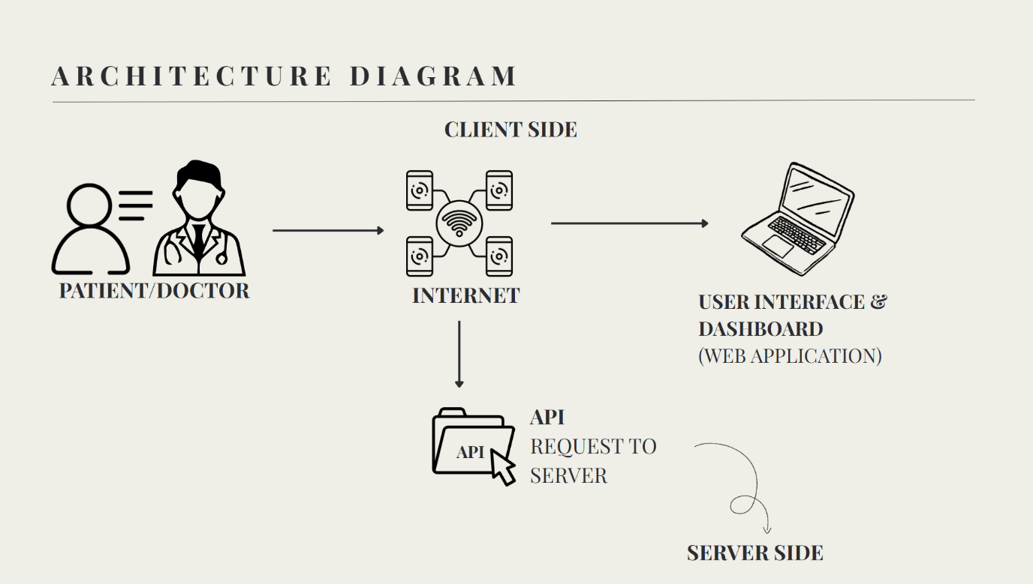

4.4 Experimental Methodology
The system development process followed several stages.
Step 1: Requirement Analysis
- Identify system requirements
- Study existing healthcare platforms
- Define project objectives
Step 2: System Design
- Design system architecture
- Create database structure
- Plan modules and functionalities
Step 3: Implementation
- Develop frontend components
- Implement backend APIs
- Connect system with the database
Step 4: Testing
- Perform module testing
- Verify system functionality
- Fix errors and improve performance
Step 5: Deployment
- Run the application on a web server
- Test the system in real-time conditions

4.5 Modules Implementation
The system is divided into several functional modules.

4.5.1 User Management Module
This module manages user registration, login authentication, and user profile information. It ensures that only authorized users can access the system.

4.5.2 Doctor Consultation Module
This module allows users to search for doctors based on specialization or illness and book appointments online.

4.5.3 Pharmacy Module
This module provides information about medicines and allows users to search for medicines available in nearby pharmacies.

4.5.4 Health Records Module
This module stores user medical records, prescriptions, and health information in a centralized database.

4.5.5 AI Health Assistant Module
This module provides basic health guidance by analyzing user inputs and offering preliminary healthcare suggestions.

4.5.6 Emergency Assistance Module
This module provides emergency contact numbers and quick access to nearby healthcare services.

4.5.7 Data Flow Diagram

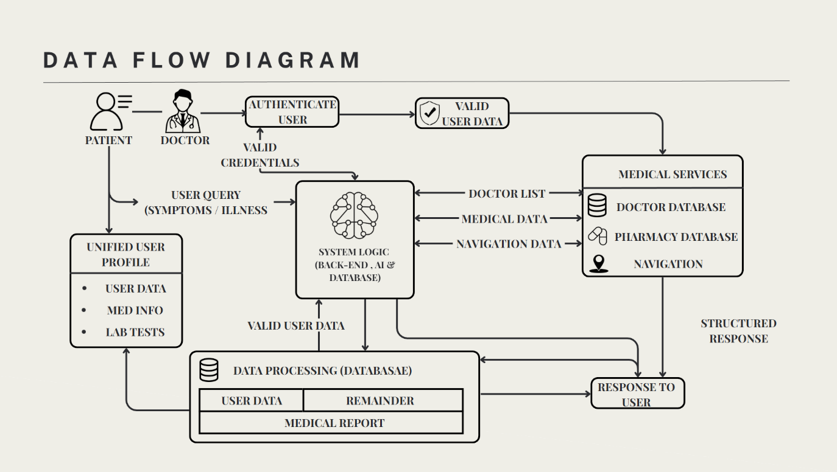

4.6 Algorithm Used
The system uses a simple health query processing algorithm to assist users.
Health Assistance Algorithm

Step 1: User enters symptoms or health-related query.
Step 2: System validates user input.
Step 3: The query is processed by the system.
Step 4: Relevant healthcare information is retrieved from the database.
Step 5: System suggests appropriate doctors or healthcare services.
Step 6: Results are displayed to the user.

This algorithm helps users quickly identify suitable healthcare services.

4.7 Security Mechanisms Used
The system implements several security mechanisms to protect user data.
- User authentication system for login verification
- Role-based access control for system users
- Secure database access to prevent unauthorized data access
- Encrypted communication (HTTPS) for data protection
These mechanisms ensure the safety of user information and system data.

4.8 Testing Methods
Several testing methods were used to verify system performance.

Unit Testing
Each module of the system was tested individually.

Integration Testing
Communication between frontend, backend, and database was tested.

System Testing
The entire system was tested to ensure proper functionality.

Performance Testing
The system response time and stability were evaluated under different conditions.

4.9 Use Case Diagram

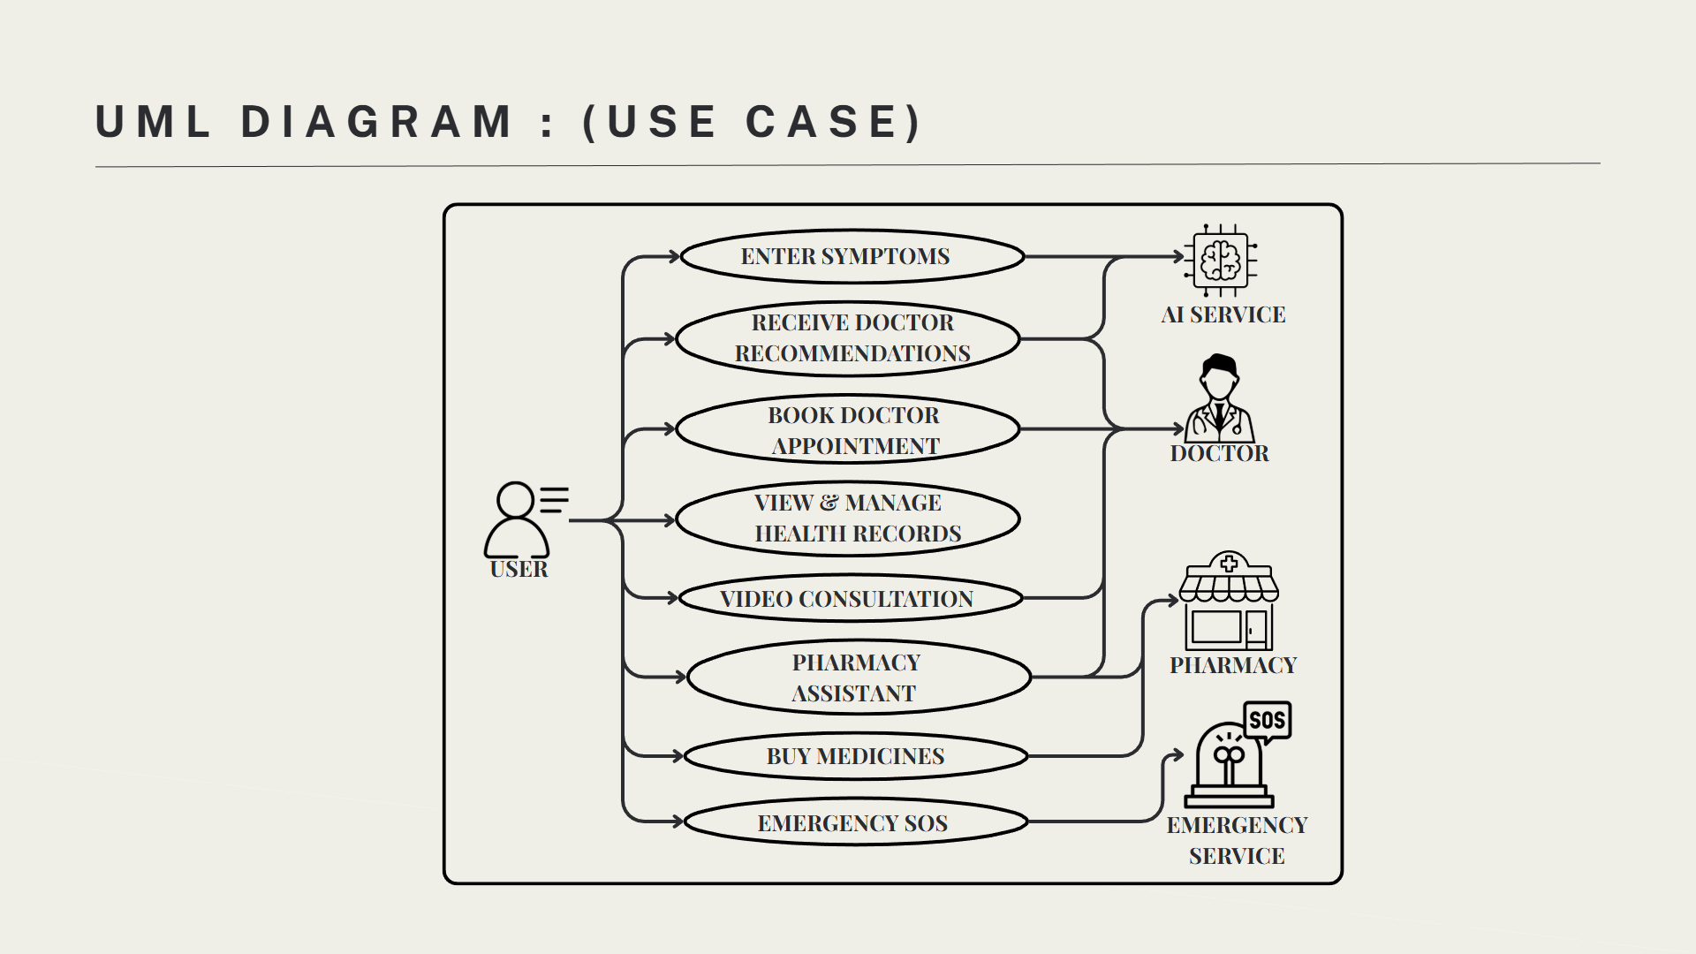

4.10 Summary
This chapter explained the materials, technologies, system architecture, development methodology, modules implementation, and security mechanisms used in developing the proposed system. The integration of modern web technologies and intelligent assistance features ensures that the system is efficient, scalable, and user-friendly.

CHAPTER 5
RESULTS AND DISCUSSION / PERFORMANCE ANALYSIS

5.1 Introduction
This chapter presents the results obtained after implementing the proposed system BAYMAX – An Intelligent Integrated System for Smart Medical Assistance. It explains how the developed modules perform in real-time conditions and evaluates the overall efficiency, usability, and performance of the system. The purpose of this chapter is to analyse whether the proposed system successfully achieves the objectives defined in the earlier chapters. The system was tested with different user inputs and scenarios to ensure that all modules function correctly and provide the expected outputs.

5.2 Implementation Results
After the development and integration of all modules, the system was tested under various conditions. The results show that the system operates correctly and provides the required healthcare services.

5.2.1 User Management Module
The user management module allows users to register and log in to the system securely. The system successfully validates user credentials and ensures that only authorized users can access the platform.

Result: The module ensures secure user authentication and efficient account management.

5.2.2 Doctor Consultation Module
The doctor consultation module enables users to search for doctors based on specialization or illness and book appointments online. The system successfully displays doctor details and allows users to schedule appointments.
Result: Users can easily find suitable doctors and book appointments without visiting hospitals physically.

5.2.3 Pharmacy Module
The pharmacy module allows users to search for medicines and view information about available medicines. The system successfully displays medicine details and provides pharmacy-related information.
Result: Users can quickly access medicine information and locate nearby pharmacies.

5.2.4 Health Records Module
This module stores user medical records, prescriptions, and healthcare information in the system database. Users can access their health records whenever needed.
Result: The system provides a centralized platform for managing digital health records.

5.2.5 AI Health Assistant Module
The AI health assistant allows users to enter symptoms or health-related queries and receive preliminary guidance. The system analyses the input and provides relevant healthcare suggestions.
Result: The AI assistant helps users obtain basic health guidance, though final medical advice should always be obtained from healthcare professionals.

5.2.6 Emergency Assistance Module
This module provides emergency healthcare contact information and quick access to nearby medical services.
Result: The system helps users quickly find emergency support when required.

5.3 System Testing Results
Different testing methods were used to evaluate the system functionality.

Module | Status
User Management | Passed
Doctor Consultation | Passed
Pharmacy Module | Passed
Health Records | Passed
AI Health Assistant | Passed
Emergency Assistance | Passed
The testing results show that all modules function correctly and meet the system requirements.

5.4 Performance Analysis
Performance analysis was conducted to evaluate the system's efficiency, response time, and reliability.

Response Time
The system responds quickly to user requests, and most operations such as doctor search, appointment booking, and medicine search are completed within a few seconds.
Usability
The system provides a simple and user-friendly interface, allowing users with minimal technical knowledge to use the platform easily.
Reliability
The system performs consistently without major errors during testing and handles user requests effectively.
Scalability
The use of modern web technologies and database systems allows the platform to support multiple users simultaneously.

5.5 Comparison with Existing Systems
Feature | Existing Systems | Proposed System (BAYMAX)
Doctor Appointment | Available | Available
Medicine Purchase | Available | Available
AI Health Assistance | Limited | Available
Emergency Support | Limited | Available
Integrated Healthcare Services | Partial | Fully Integrated

The comparison shows that the proposed system provides more integrated healthcare services compared to many existing platforms.

5.6 Discussion
The results indicate that the proposed system successfully achieves its objective of providing an integrated healthcare assistance platform. The system simplifies access to healthcare services and reduces the effort required for users to find doctors, medicines, and healthcare support. The integration of intelligent assistance features improves user experience and helps users obtain preliminary health guidance. Overall, the system proves to be technically feasible, efficient, and beneficial for improving healthcare accessibility.

CHAPTER 6
SUMMARY AND CONCLUSION

6.1 Summary of the Work

The project “BAYMAX – An Intelligent Integrated System for Smart Medical Assistance” was developed with the objective of improving healthcare accessibility by integrating multiple medical services into a single digital platform. The system aims to simplify the process of finding doctors, booking appointments, accessing pharmacy services, and receiving basic healthcare guidance. During the development of the project, several stages were completed including requirement analysis, system design, implementation, testing, and performance evaluation. The system was developed using modern web technologies such as React.js for the frontend, Node.js and Express.js for the backend, and MongoDB for the database. These technologies provide scalability, efficiency, and flexibility for the application. The platform includes several functional modules such as User Management, Doctor Consultation, Pharmacy Services, Health Records Management, AI Health Assistant, and Emergency Assistance. Each module was designed to provide specific healthcare services and improve the overall user experience. The AI health assistant helps users obtain basic health guidance by analysing symptoms and suggesting possible healthcare actions. However, the system is designed only to provide preliminary assistance and does not replace professional medical consultation. The integration of digital healthcare services helps users save time, reduce effort, and access medical services more conveniently. The testing results confirmed that the system functions correctly and efficiently. The platform provides a user-friendly interface and allows users to access healthcare services easily through a web-based environment.

6.2 Conclusion

In conclusion, the BAYMAX healthcare assistance platform successfully demonstrates how modern digital technologies can improve healthcare accessibility and convenience. By integrating doctor consultation, appointment booking, pharmacy services, and healthcare guidance into a single system, the platform simplifies the process of accessing medical services. The system provides a centralized platform where users can manage different healthcare needs efficiently. The use of intelligent assistance features enhances the functionality of the system and helps users obtain preliminary healthcare guidance when required. Although the system provides useful healthcare support, it is important to note that the AI-based assistance should only be used as a supportive tool. Final medical decisions and diagnoses should always be made by qualified healthcare professionals. Overall, the proposed system provides a practical, user-friendly, and scalable healthcare assistance solution that can help improve healthcare accessibility and user convenience in modern digital environments.

BIBLIOGRAPHY / REFERENCES
1. Journal References
- Topol, E. (2019). High-performance medicine: The convergence of human and artificial intelligence. Nature Medicine, 25(1), 44–56.
- Jiang, F., Jiang, Y., Zhi, H., Dong, Y., Li, H., Ma, S., Wang, Y., Dong, Q., Shen, H., & Wang, Y. (2017). Artificial intelligence in healthcare: Past, present and future. Stroke and Vascular Neurology, 2(4), 230–243.

2. Book References

- Russell, S., & Norvig, P. (2020). Artificial Intelligence: A Modern Approach. Pearson Education.
- Reddy, C. K., & Aggarwal, C. C. (2015). Healthcare Data Analytics. Chapman and Hall/CRC.

- Internet Sources

- Apollo Hospitals – Apollo 24|7 Healthcare Platform
https://www.apollo247.com
- React Official Documentation
https://react.dev
- Node.js Official Documentation
https://nodejs.org
- MongoDB Official Documentation
https://www.mongodb.com
- Express.js Documentation
https://expressjs.com

APPENDIX
Appendix A – System Screenshots
This section contains screenshots of the developed BAYMAX healthcare assistance system to demonstrate the user interface and functionality of the application. The screenshots help in understanding how different modules of the system operate and how users interact with the platform.
Some of the important screenshots that can be included are:
- Home Page – Displays the main interface of the BAYMAX platform with navigation options and healthcare services.
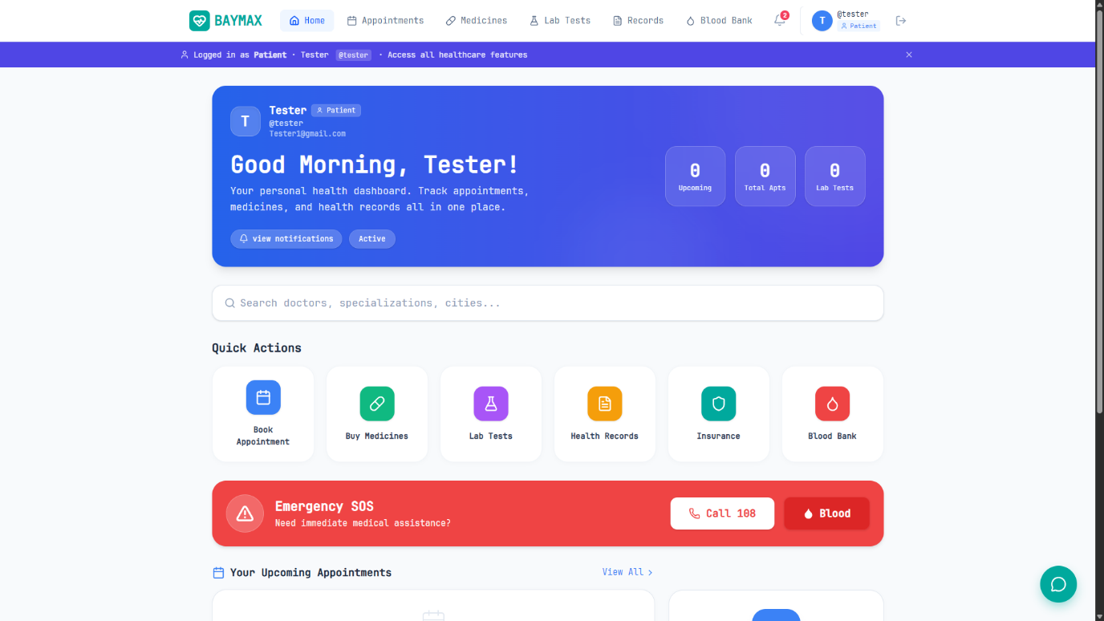

- User Registration Page – Allows new users to create an account in the system.
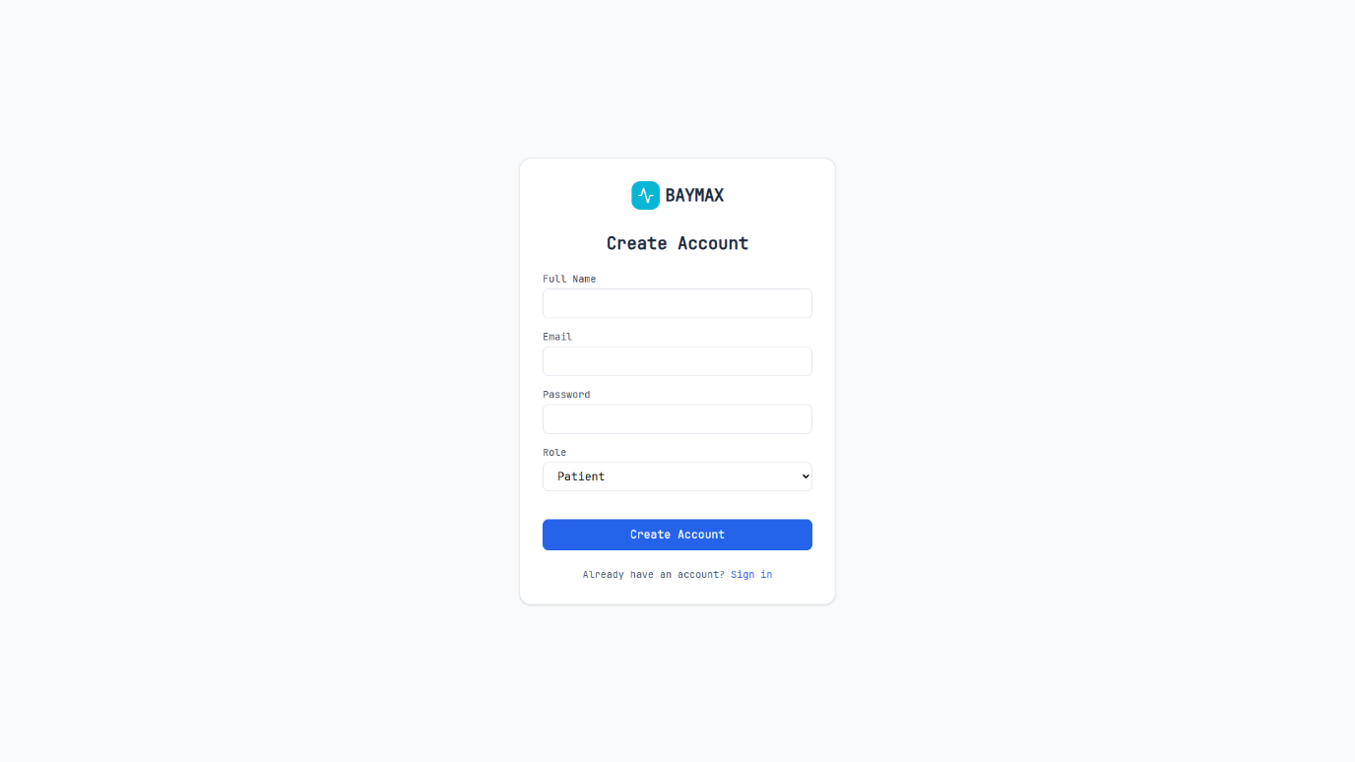

- User Login Page – Enables registered users to log into the system securely.
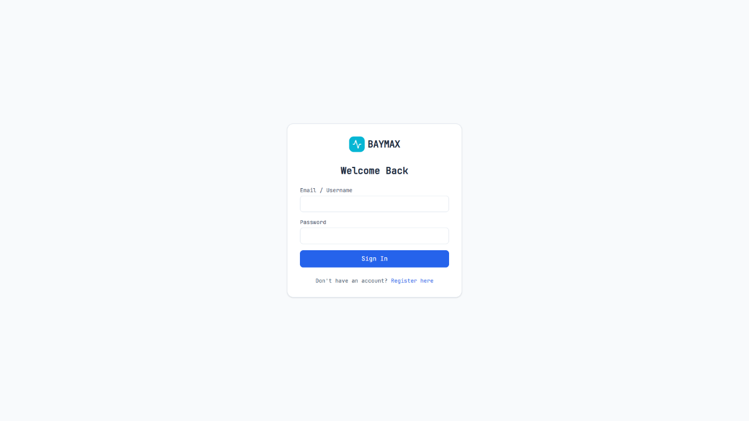
- Patient Dashboard – Shows the main dashboard where users can access healthcare services such as doctor consultation, medicine purchase, and health records.


- Doctor Appointment Page – Displays the list of available doctors and allows users to book appointments.
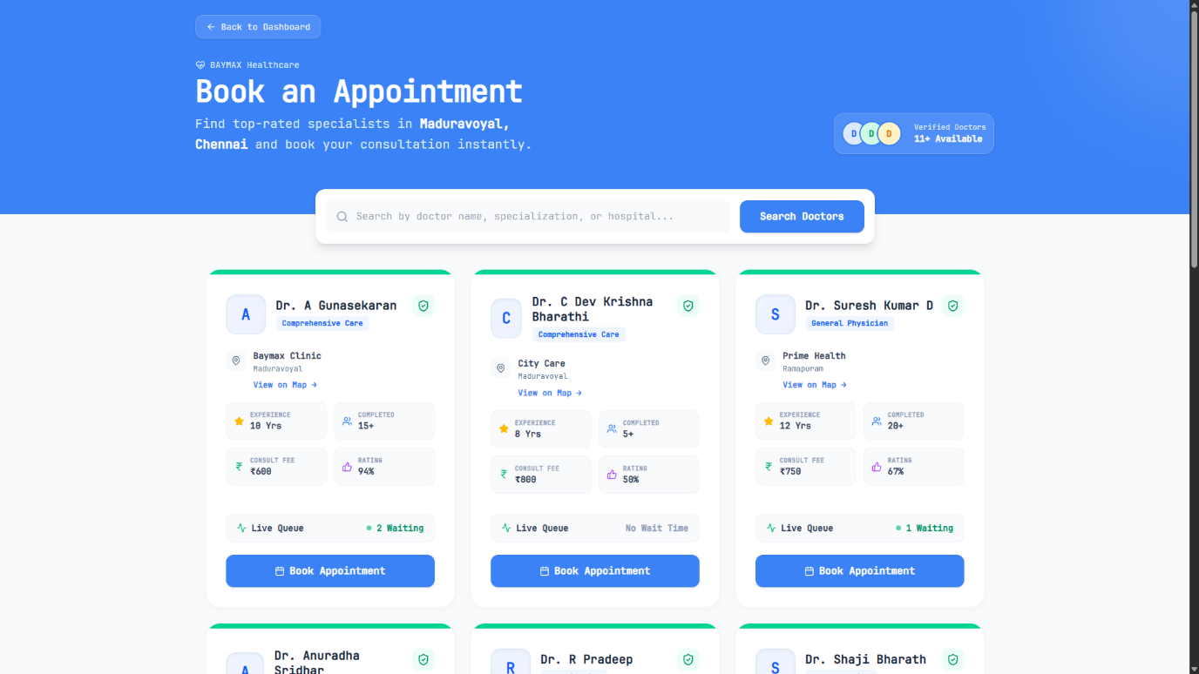

- Buy Medicines Page – Shows medicine details and pharmacy information.
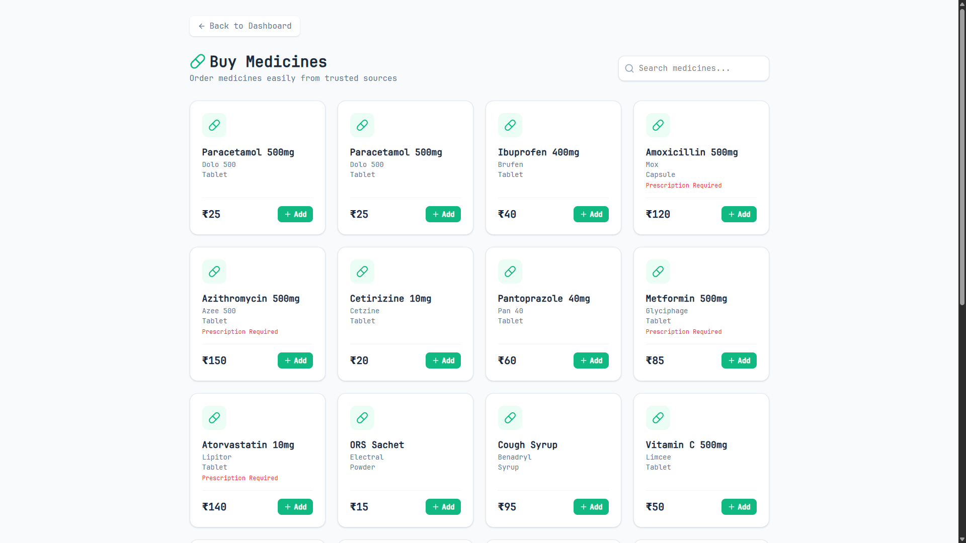

- Health Records Page – Displays user medical records and prescriptions.
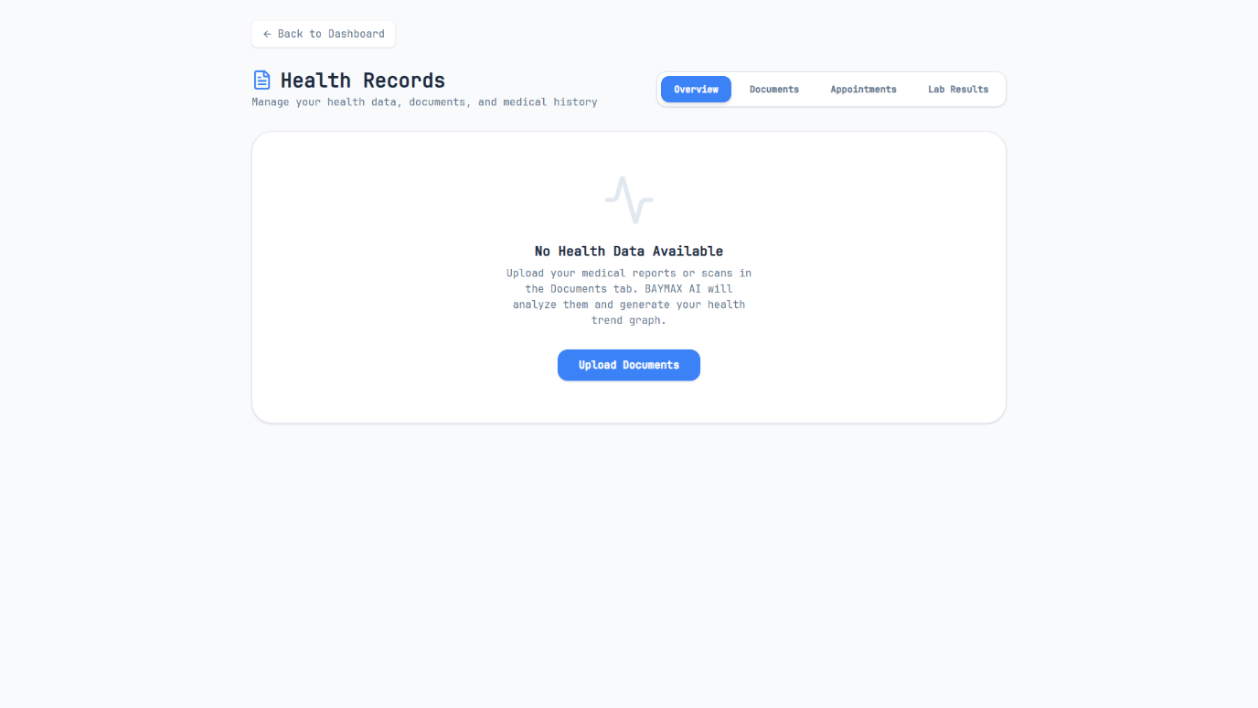

- AI Health Assistant Interface – Shows the chatbot or AI interface that provides basic healthcare guidance.
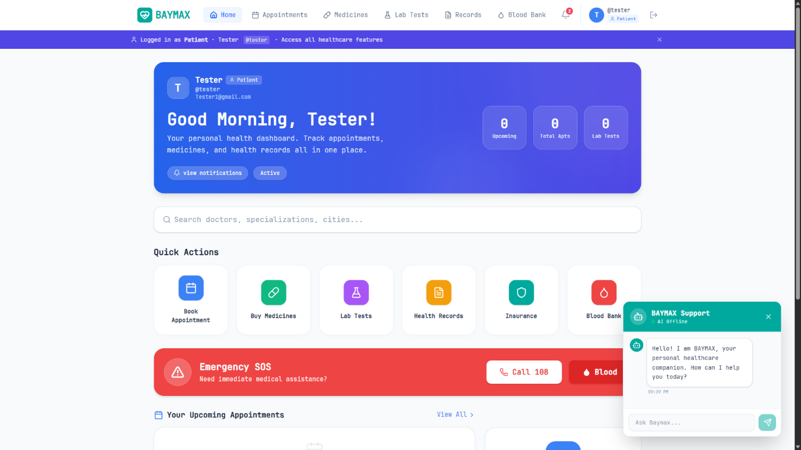

- Emergency Assistance Page – Displays emergency contact numbers and healthcare support services.
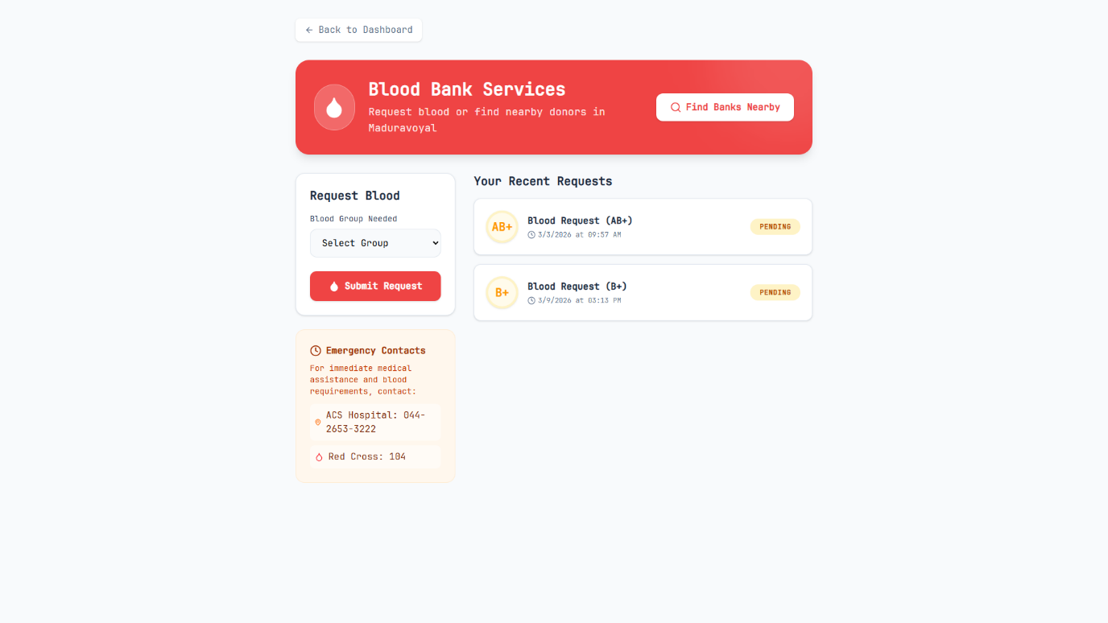

Appendix B – Sample Test Cases
The following table shows sample test cases used to verify the functionality of the system.

Test Case ID | Module | Test Description | Expected Result | Status
TC01 | User Registration | User enters valid details and registers | User account created successfully | Passed
TC02 | User Login | User enters valid login credentials | User logged into the system | Passed
TC03 | Doctor Search | User searches for doctors by specialization | List of doctors displayed | Passed
TC04 | Appointment Booking | User selects doctor and books appointment | Appointment confirmed | Passed
TC05 | Medicine Search | User searches for medicine | Medicine information displayed | Passed
TC06 | Health Records | User views health records | Records displayed correctly | Passed
TC07 | AI Health Assistant | User enters health query | System provides health suggestion | Passed
TC08 | Emergency Assistance | User accesses emergency module | Emergency contacts displayed | Passed

The test results indicate that all system modules function correctly and meet the required system objectives.

